Q1

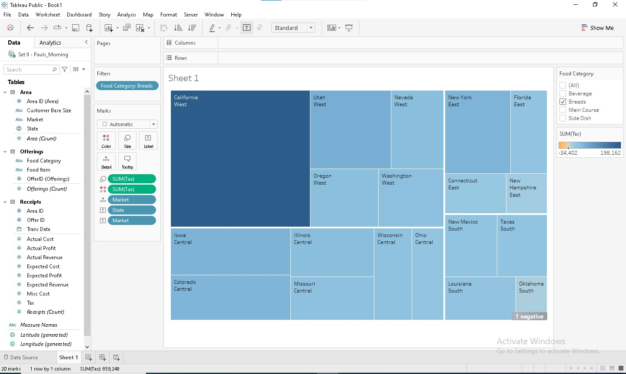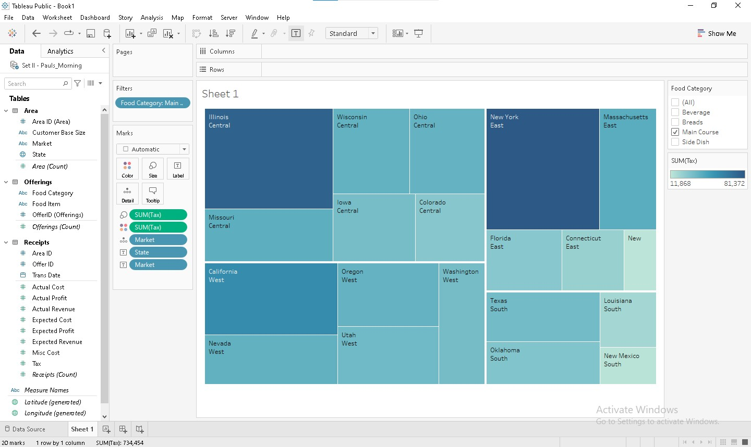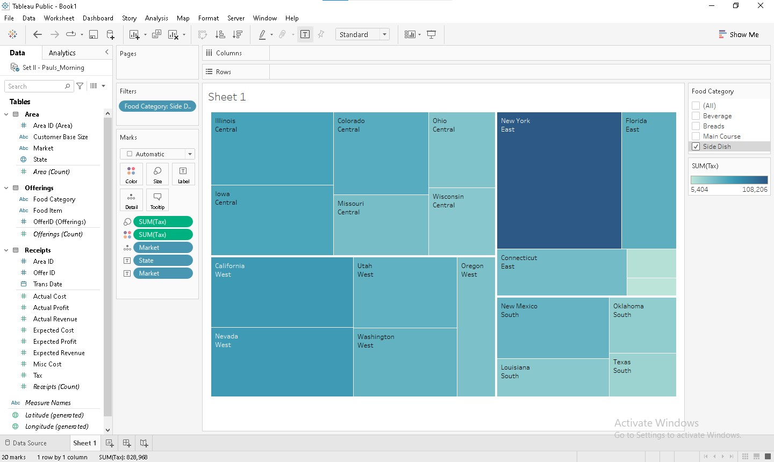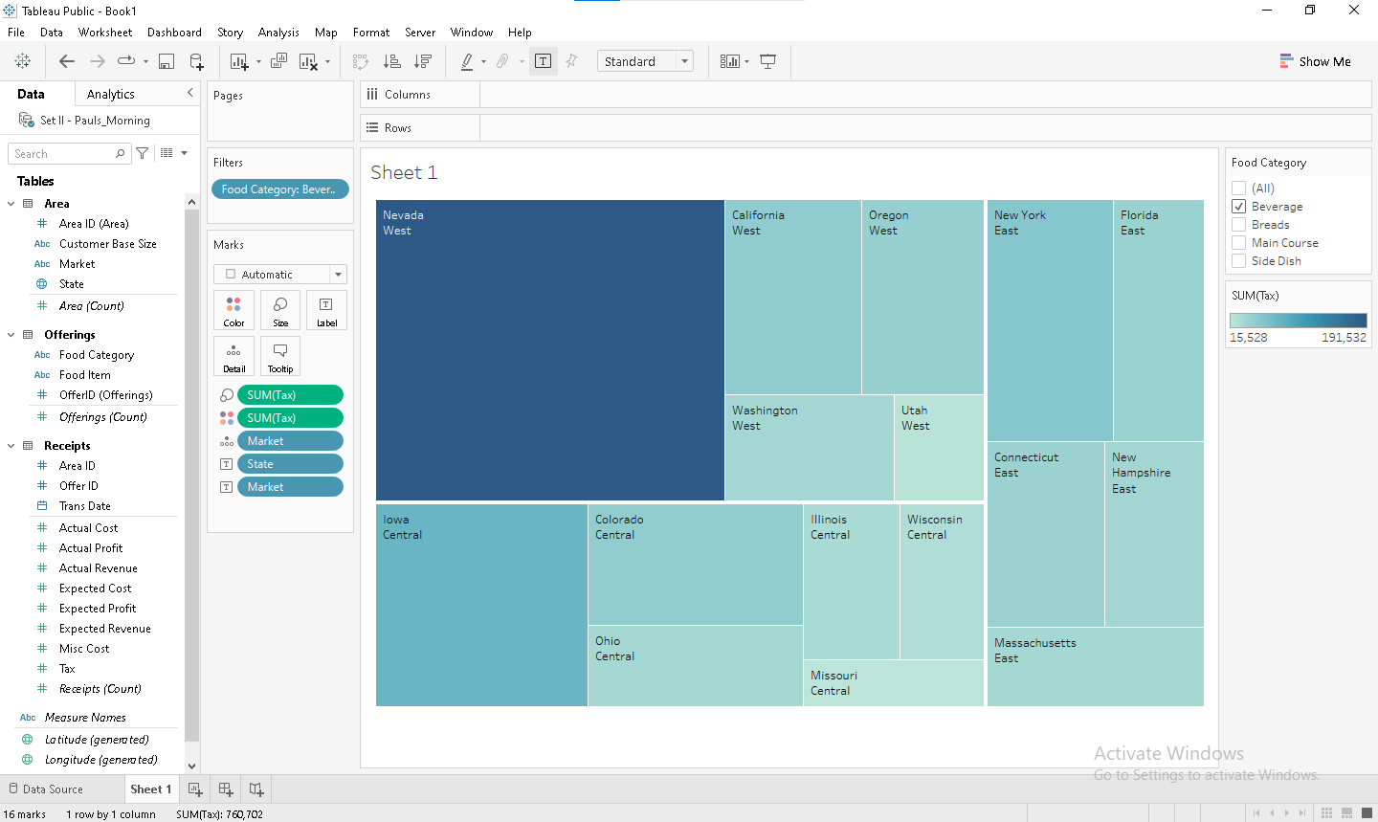

BY ANALYSING ALL THE FOOD CATEGORY FILTERS SET ON TREE MAP OF TAX BY STATE AND GROUPED BY MARKET,

WE CAN CONCLUDE THAT THERE ARE FOUR MARKETS: CENTRAL , EAST, WEST , SOUTH. FROM THESE, THE CENTRAL MARKET IS ABSENT FOR FOOD CATEGORY : BEVERAGE.

Q1 2

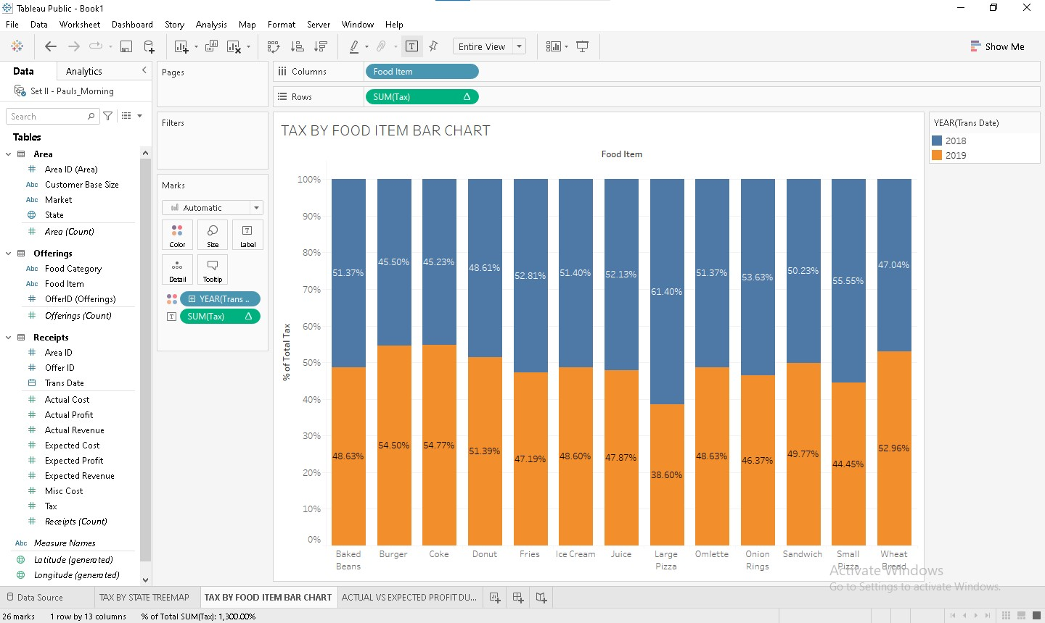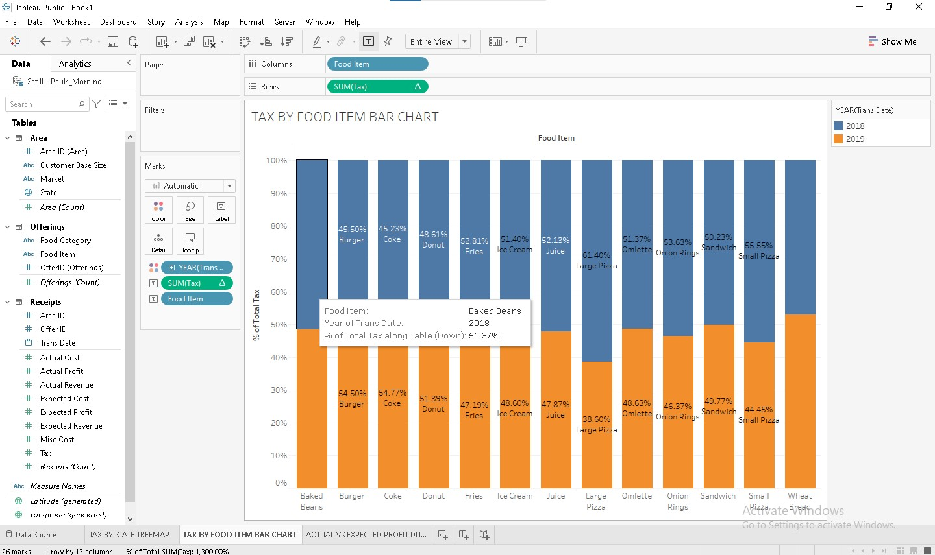

ABOVE IS STACKED BAR CHART FOR TAX BY FOOD ITEM FOR YEARS 2019, 2020. WE CONCLUDE THAT FOR FOOD ITMES:

BURGER , COKE, DOUNT , WHEAT BREAD THE 2019 TAX % IS MORE THAN 50 THAN 2018.

Q1 3

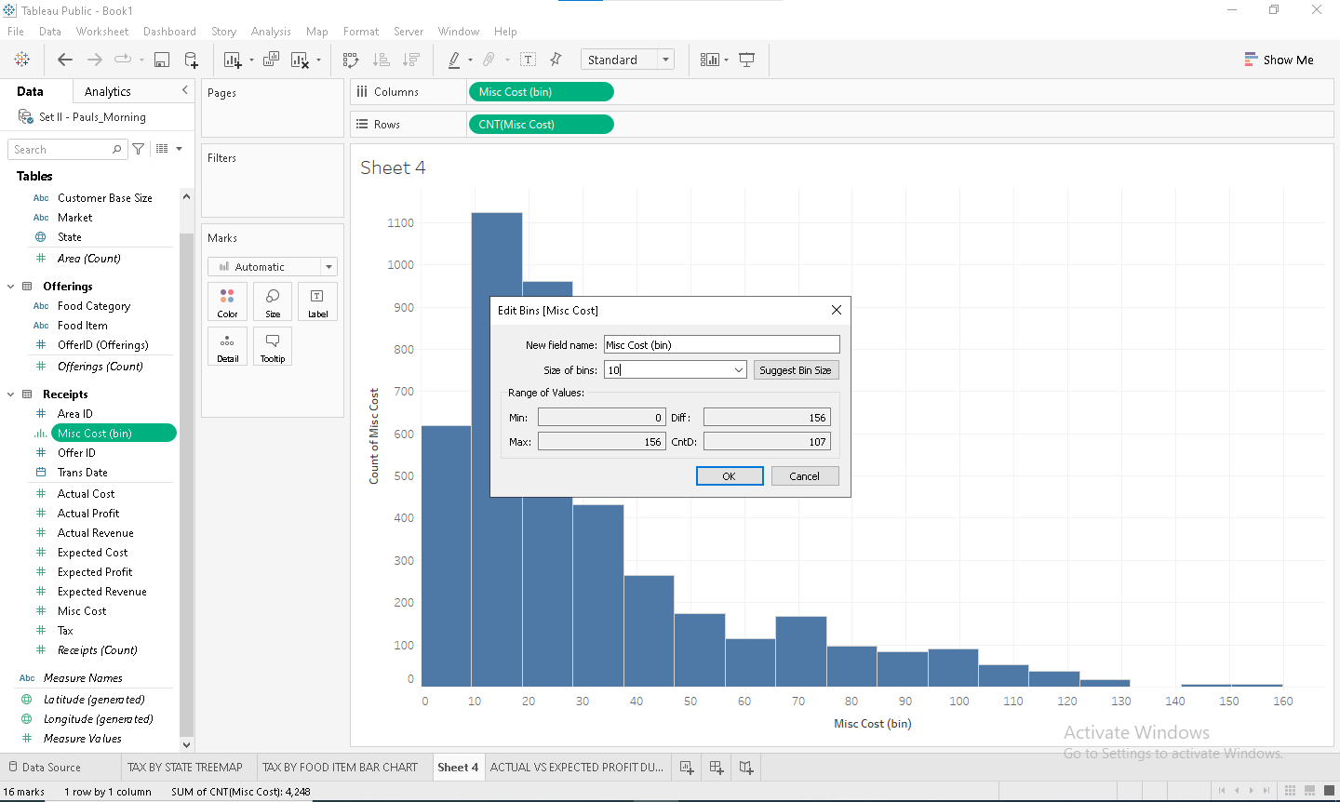

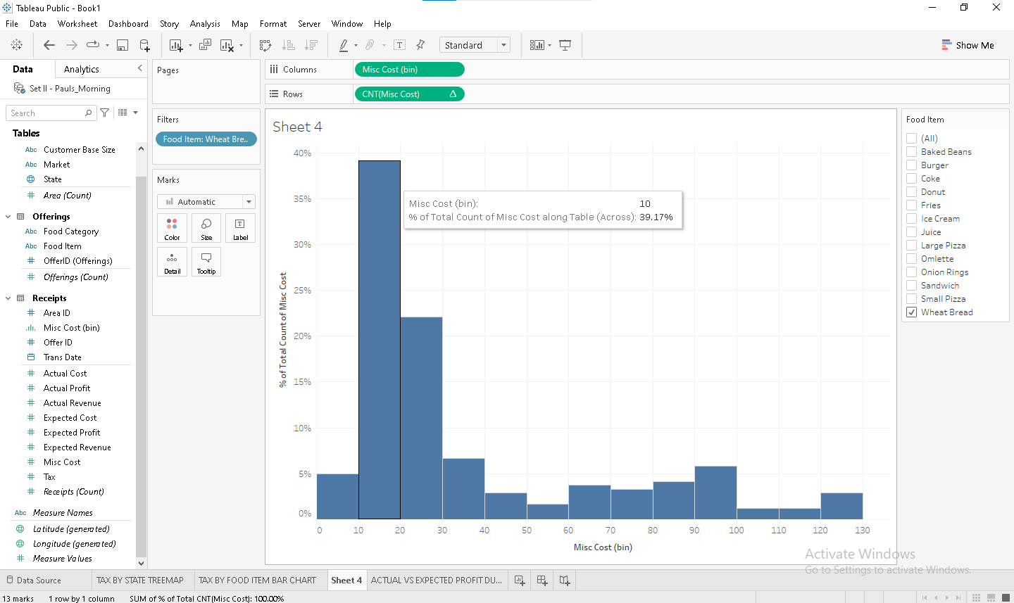

FROM ABOVE WE CONCLUDE, %COUNT OF TOTAL MISC COST BIN 10 FOR WHEAT BREAD IS 39.17%

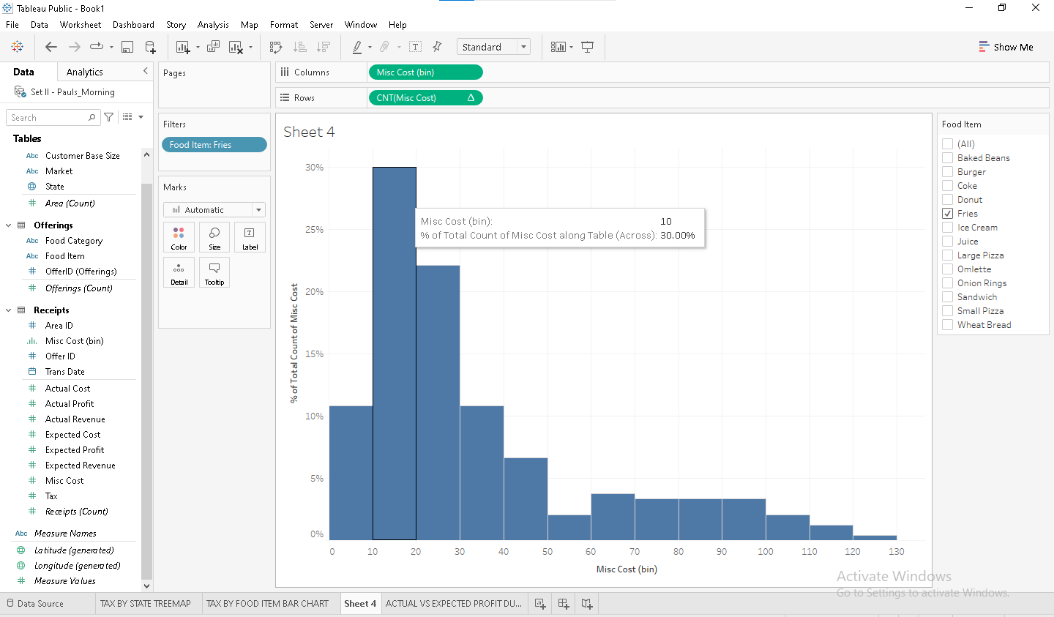

FROM ABOVE WE CONCLUDE, %COUNT OF TOTAL MISC COST BIN 10 FOR FRIES IS 30%.

HENCE %COUNT OF WHEAT BREAD IS GREATER

Q1 4

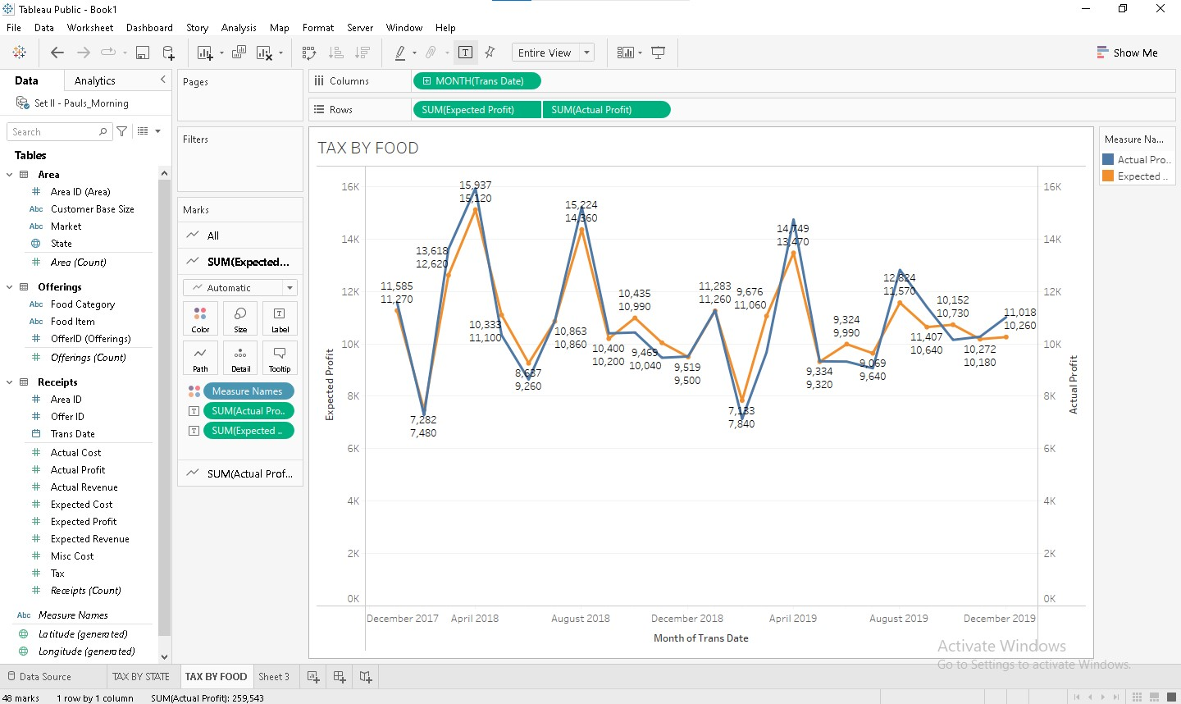

ABOVE IS DUAL LINE CHART OF ACTUAL PROFIT VS EXPECTED PROFIT MONTHLY. WE CAN CONCLUDE THAT,

FOR 14 MONTHS THE ACTUAL PROFIT IS GREATER THAN EXPECTED PROFIT

Q2 1

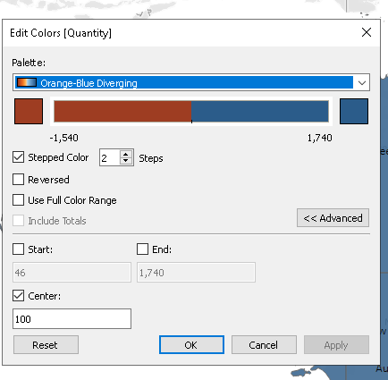

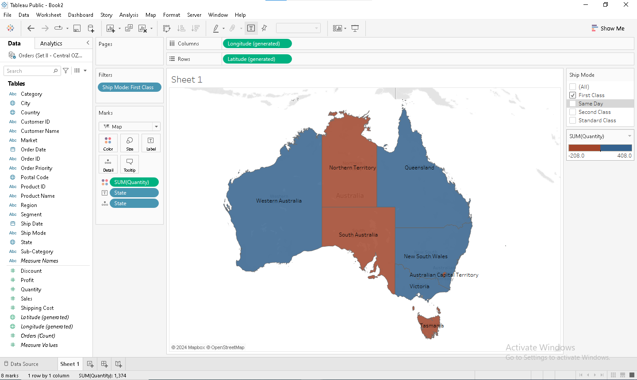

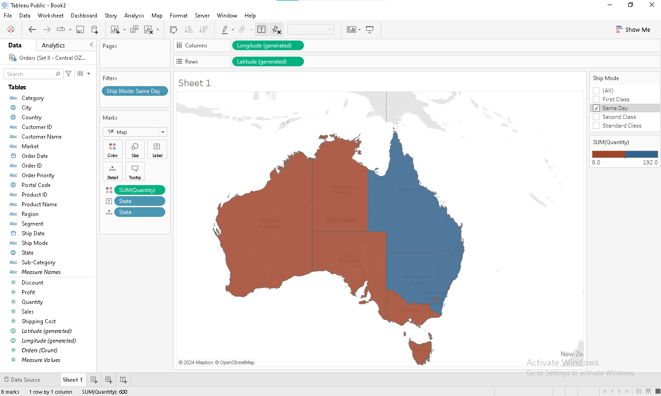

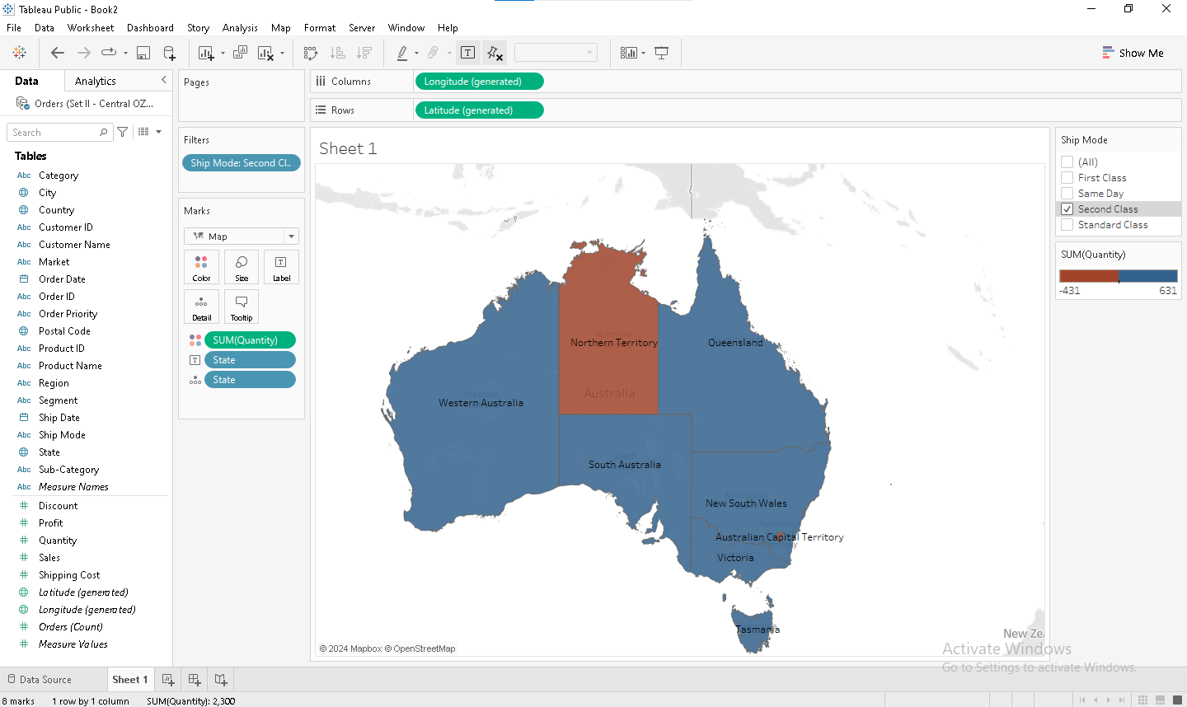

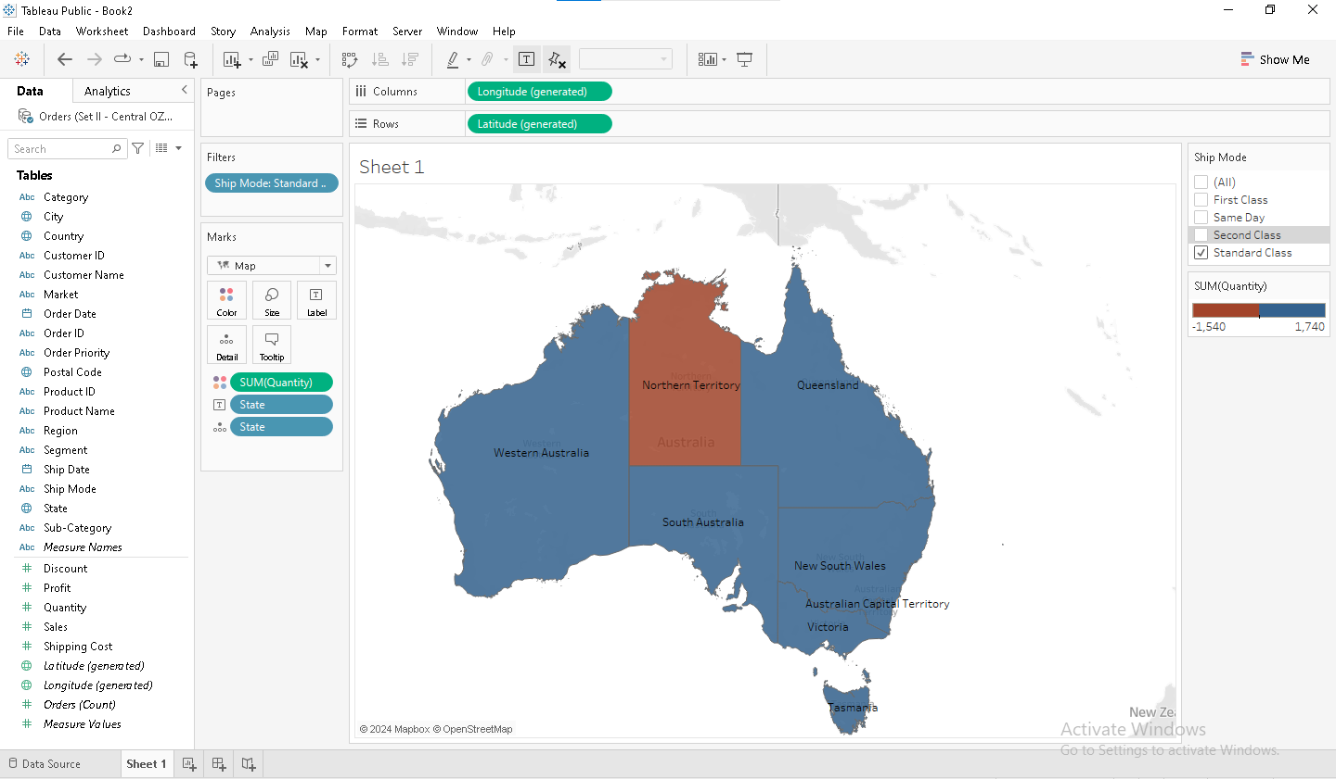

ABOVE IS THE STATEWISE QUANTITY GEO SOLID MAP FILTERED BY SHIP MODE AND DUAL COLOR WITH RED COLOR FOR QUANTITY VALUE BELOW 100 AND BLUE COLOR FOR QUANITY VALUE ABOVE 100.

WE CONCLUDE THAT, FOR SHIP MODE SECOND CLASS AND STANDARD CLASS THE QUNATITY VALUE BELOW 100 CONTAINS ONLY ONE STATE NAMED NORTHERN TERRITORY.

Q2 2

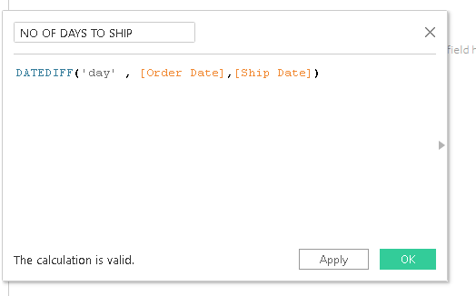

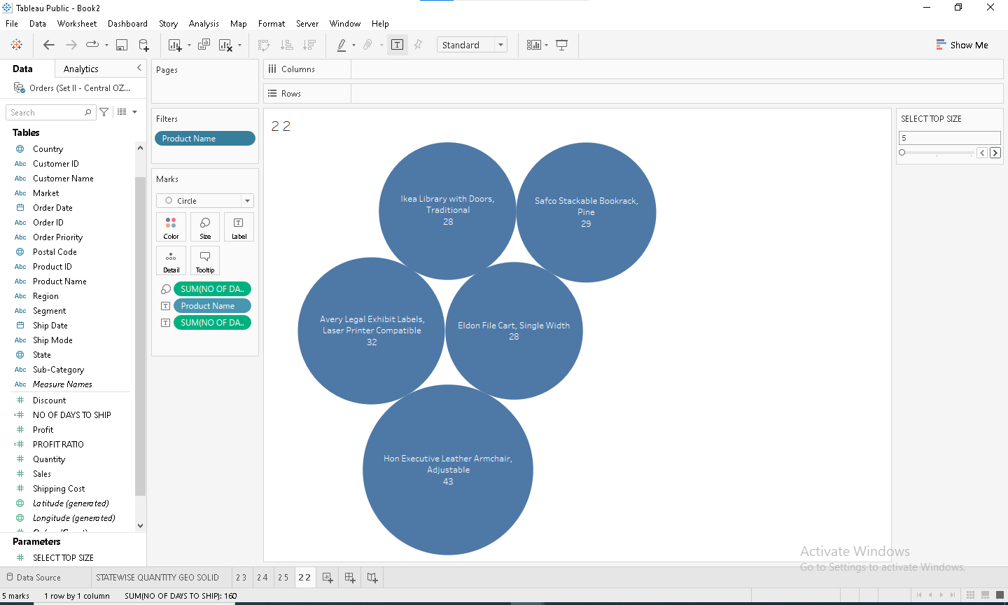

ABOVE IS BUBBLE CHART FOR TOP 5 PRODUCTS BASED ON SHIPPING DAYS REQUIRED

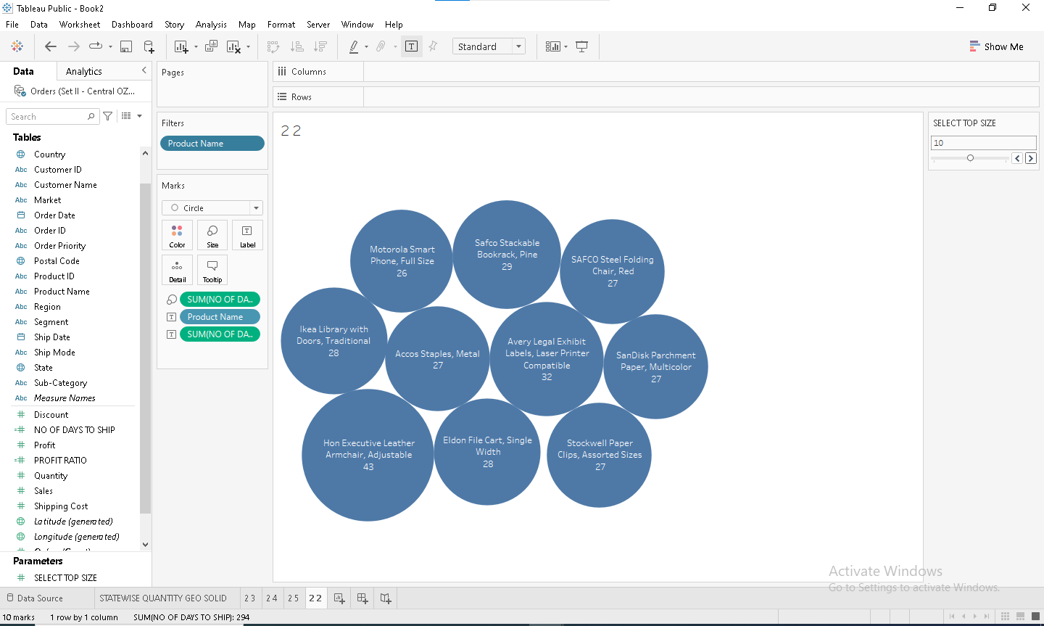

ABOVE IS BUBBLE CHART FOR TOP 10 PRODUCTS BASED ON SHIPPING DAYS REQUIRED

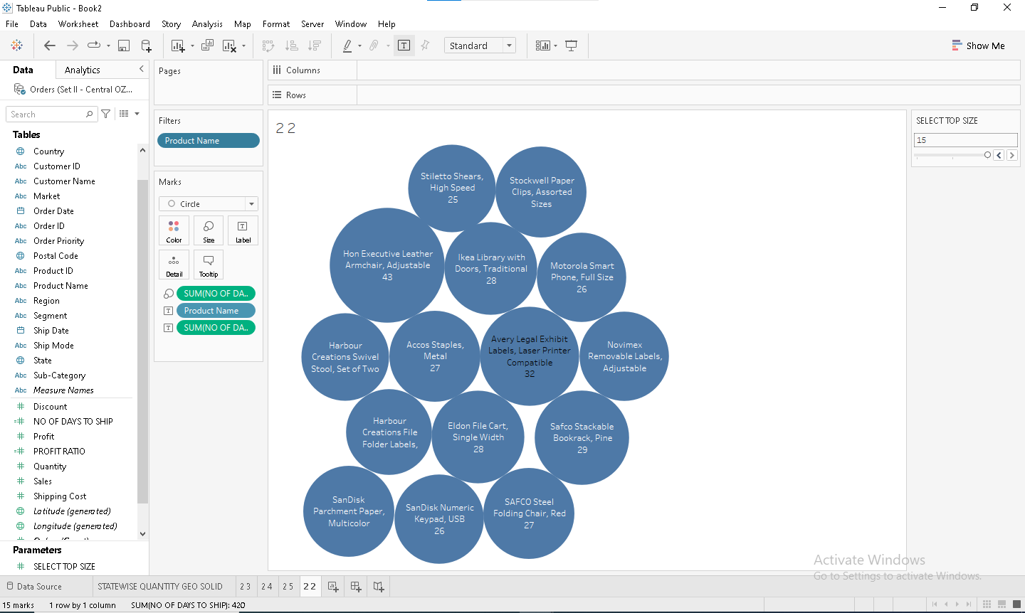

ABOVE IS BUBBLE CHART FOR TOP 15 PRODUCTS BASED ON SHIPPING DAYS REQUIRED

Q2 3

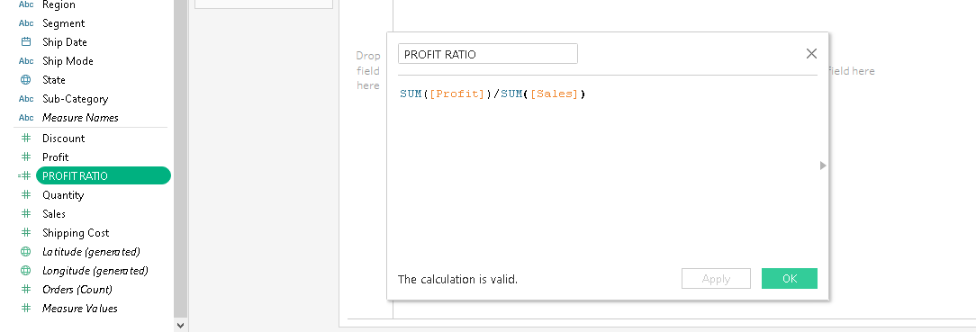

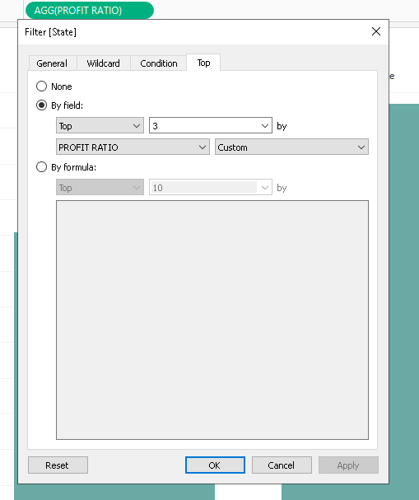

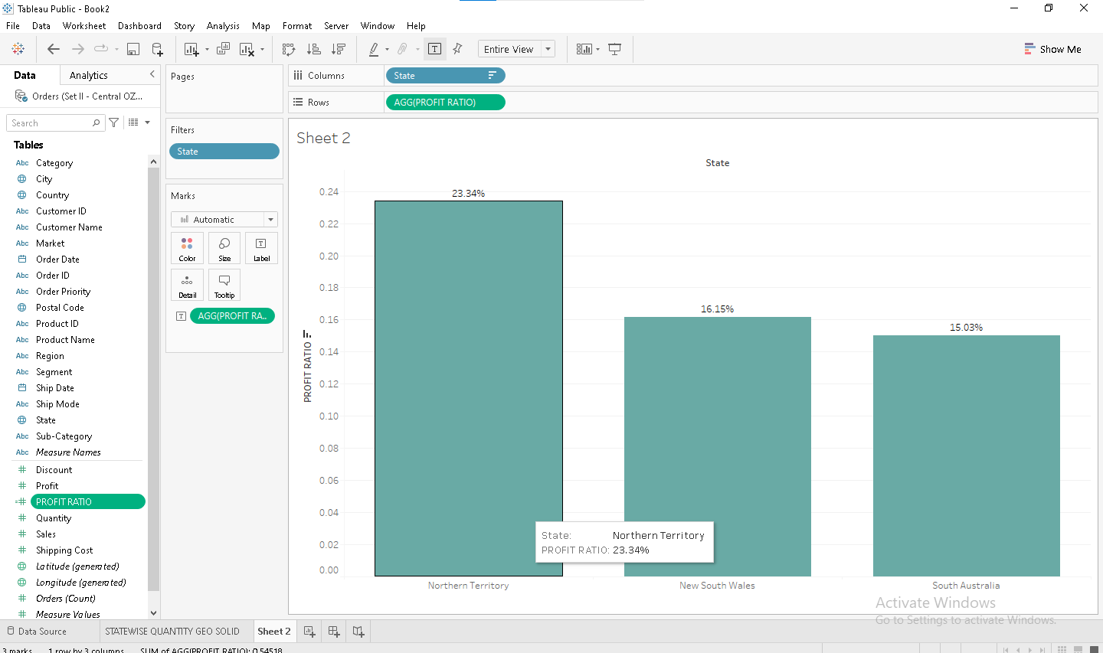

ORDER PRIORITY CRITICAL

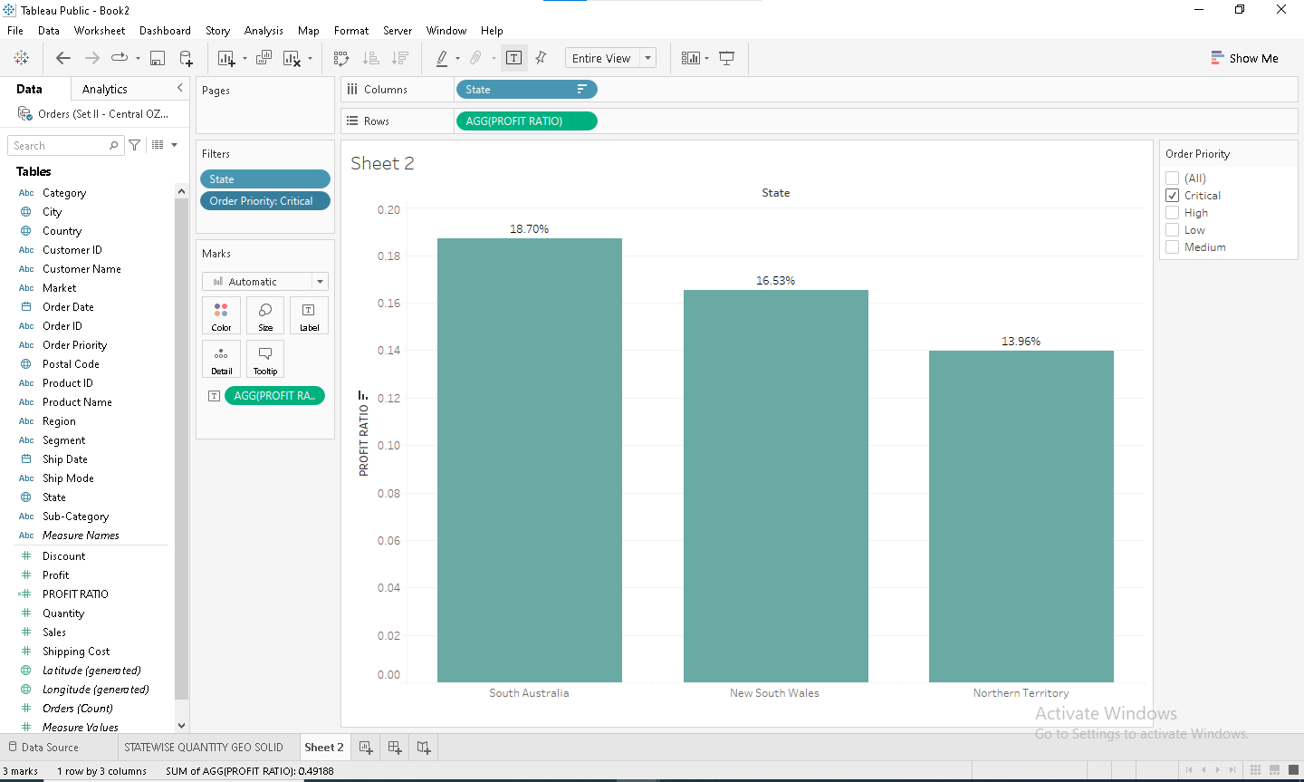

ORDER PRIORITY HIGH

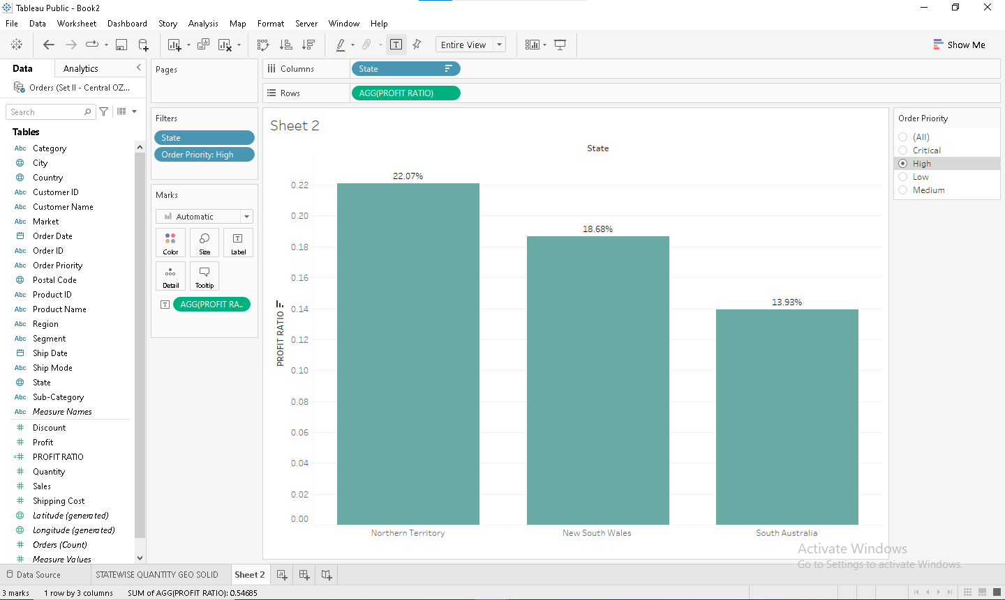

ORDER PRIORITY LOW

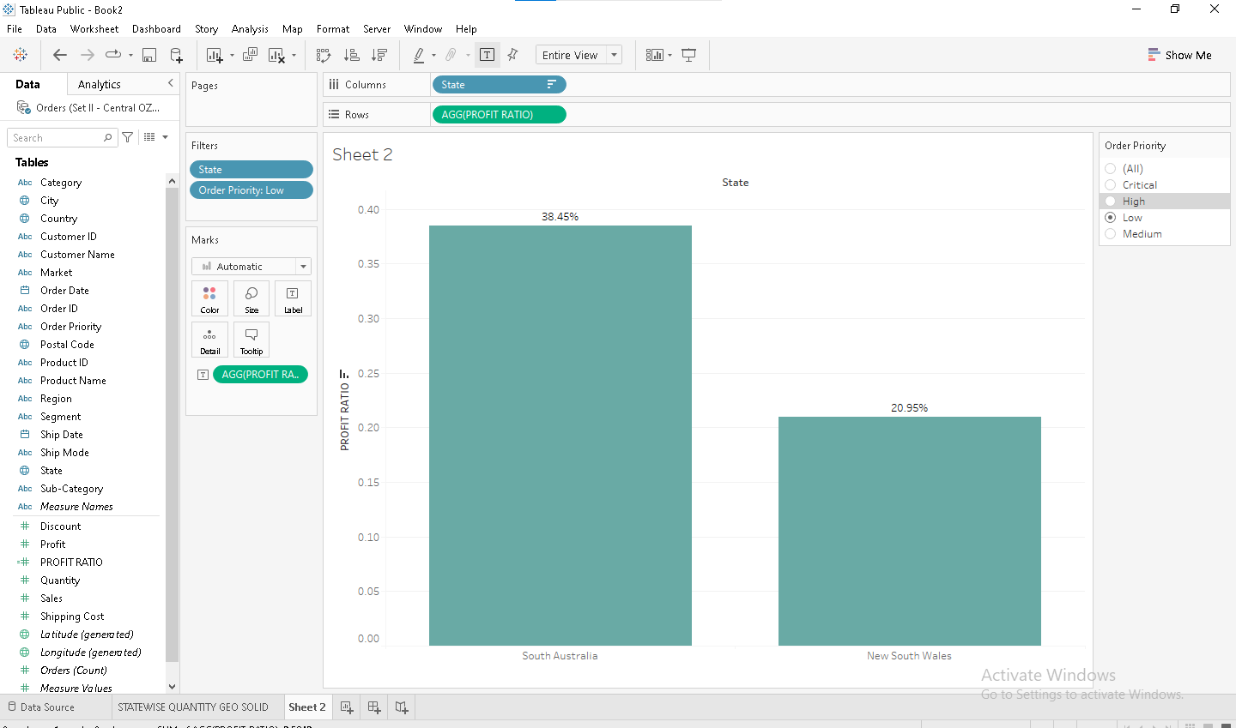

ORDER PRIORITY MEDIUM

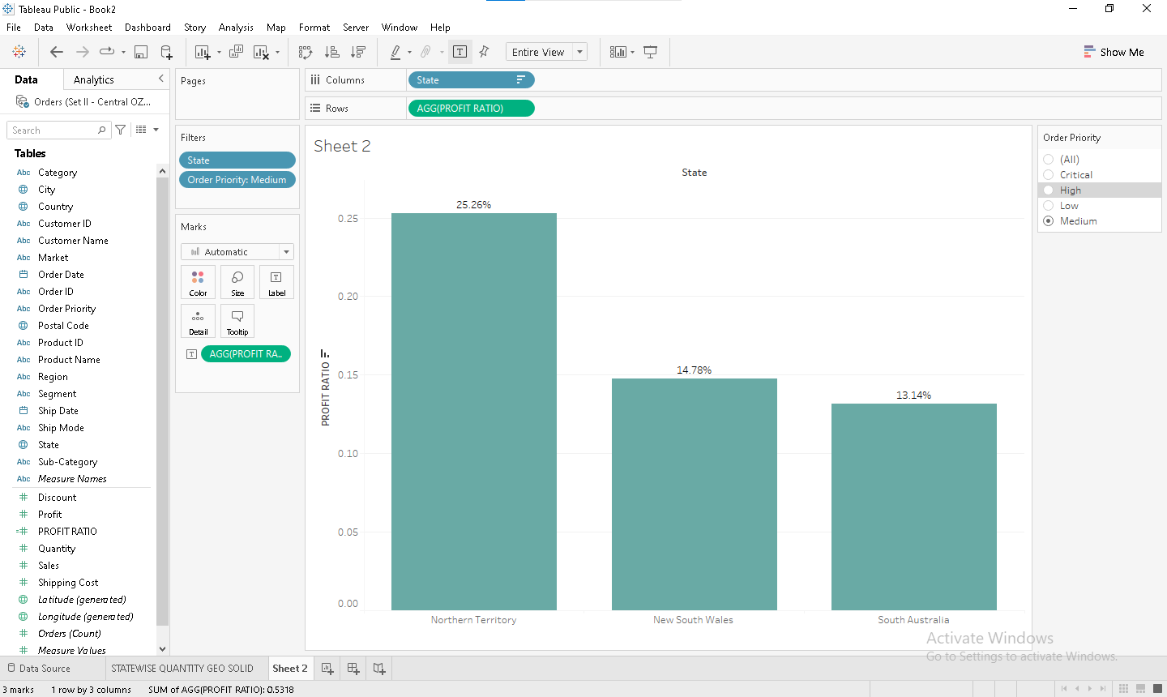

Q2 4

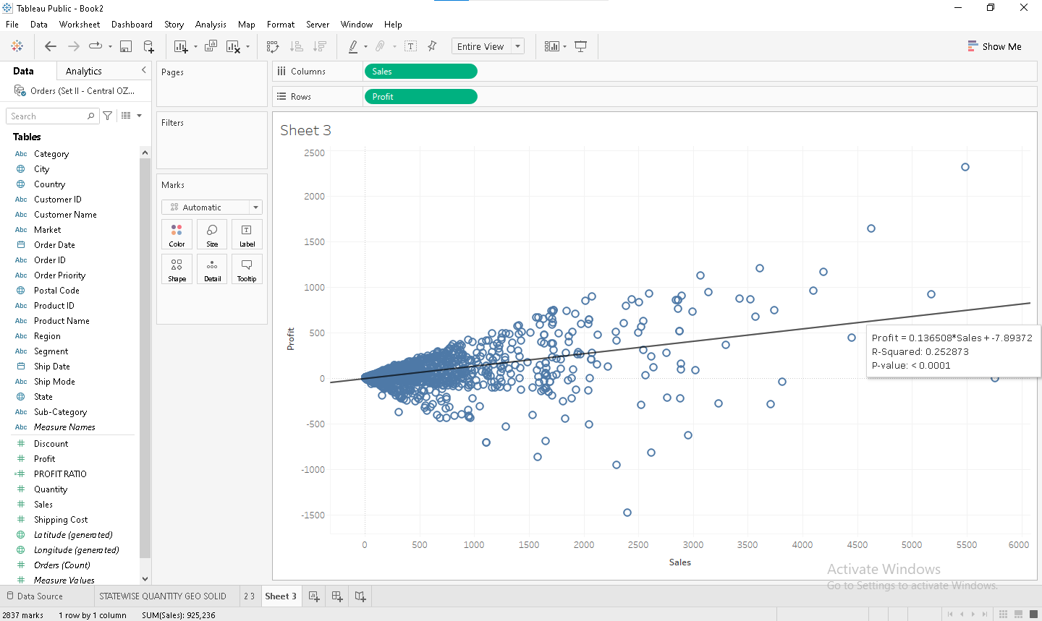

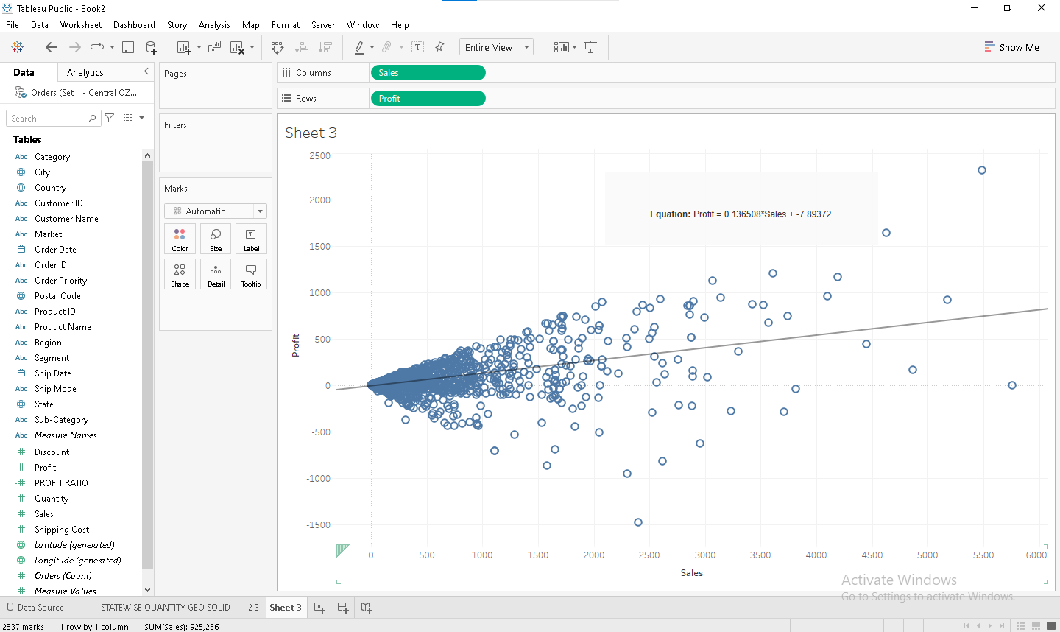

ABOVI IS SCATTER PLOT FOR SALES VS PROFIT WITH TREND LINE.

HERE **R SQUARED VALUE IS: 0.252873**

AND EQUATION OF LINE FOR PROFIT IS **(PROFIT= 0.136508*SALES+7.89372)**

**FOR SALES =5500 PROFIT WILL BE**

**PROFIT= 0.136508*SALES+7.89372**

**PROFIT= 0.136508*5500+7.89372**

**PROFIT=758.68772**

**FOR PROFIT=1800 SALES SHOULD BE**

**SALES=(PROFIT-7.89372)/0.136508**

**=(1800-7.89372)/0.136508**

**SALES=13,128**

**Q2 5**

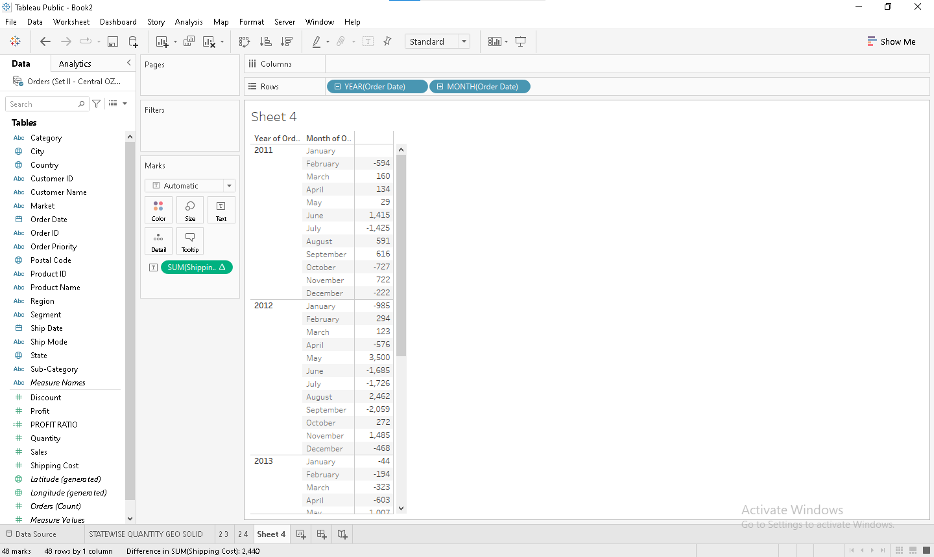

**ABOVE IS RUNNING TOTAL FOR SHIPPING COST AND ORDER DATE FOR YEAR AND MONTH**

**IT MEANS FOR EVERY MONTH OF YEAR THE TOTAL IS COUNT.**

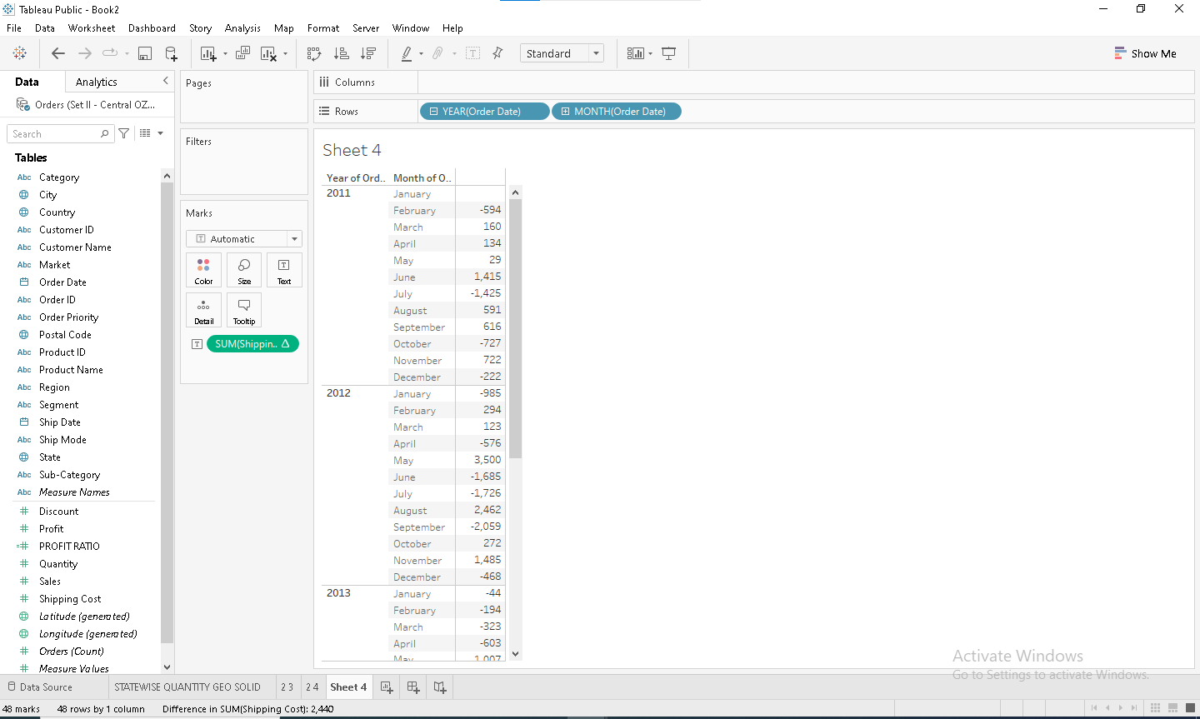

**ABOVE IS THE DIFFERNCE FOR SHIPPING COST AND ORDER DATE**

**PER MONTH AND YEAR DIFFERNCE IS DISPLAYED**

**EXCEL**

**Q3**

**QUESTION 1**

**3**

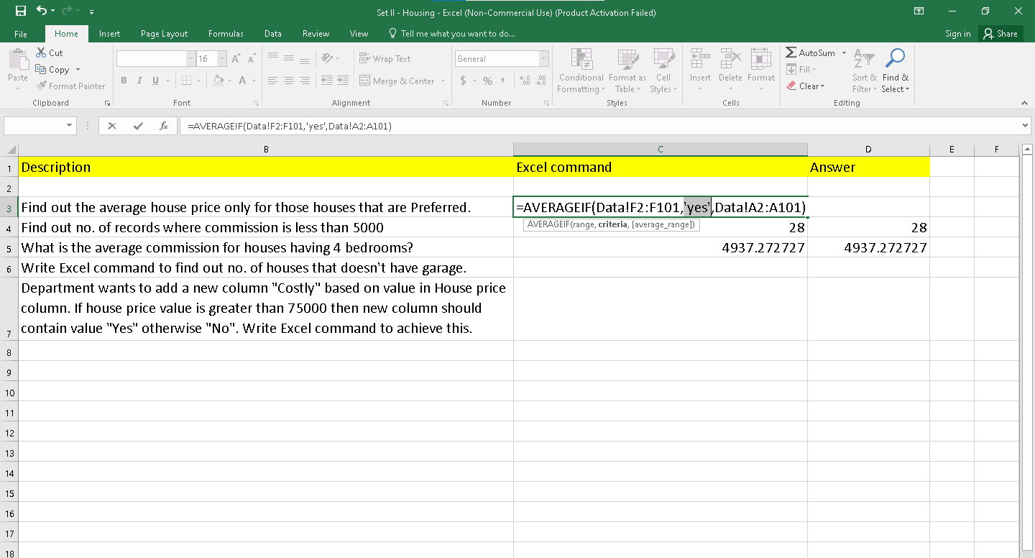

**4**

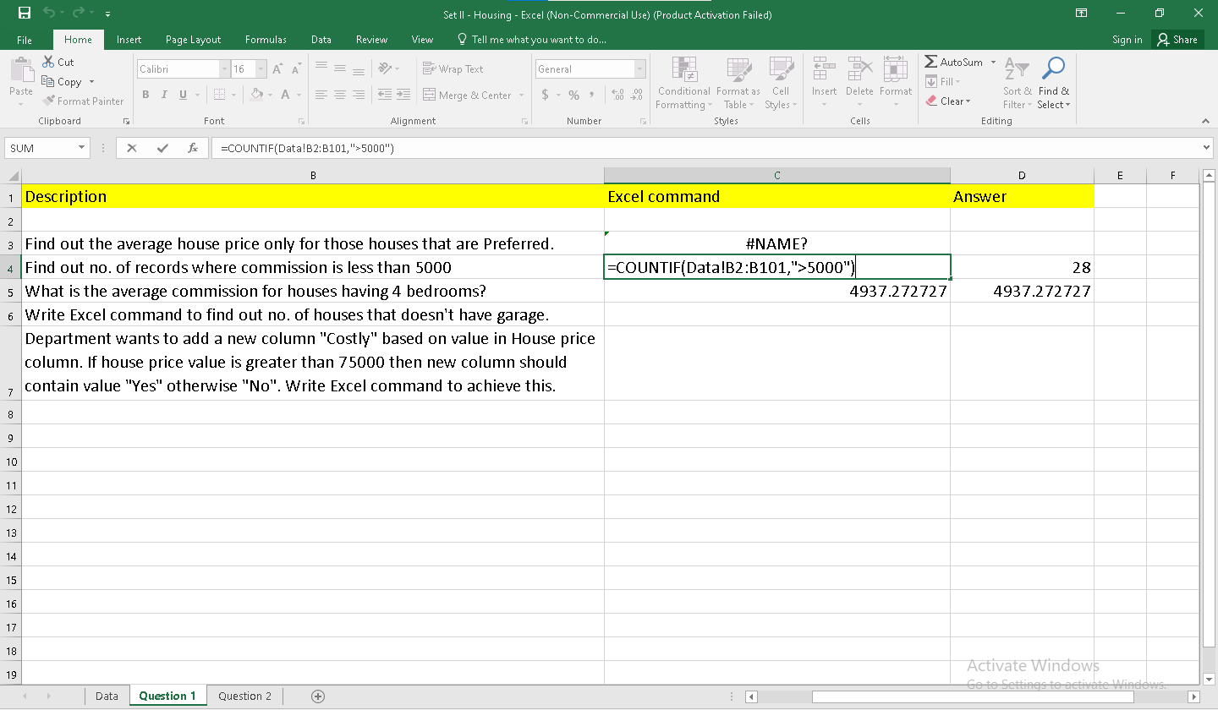

**5**

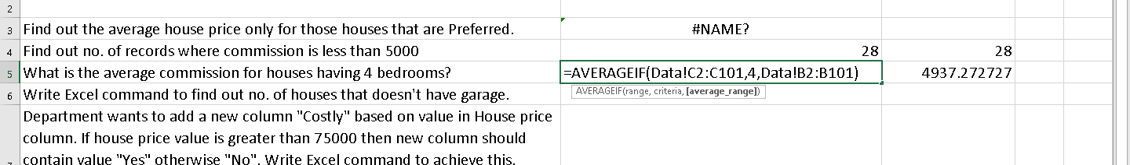

Q2

